Table of Contents

Registering Patient 3

Figure 1: Search Dialog box 4

Figure 2: Search by ID 5

Figure 3: Search Patient by Name 6

Figure 4: Search Patient by ID number 7

Figure 5: Create New Patient Demography dialog box 7

Figure 6: Create Patient Demography 8

Updating Patient Demography 10

Figure 7: Search Patient-Updating Demography 10

Figure 8: Update Patient Demographic (with existing record) 11

Viewing Patient Demography 12

Figure 9: View Demography Menu Window 12

Figure 10: Sample Label 13

Figure 11: Doctors’ Note 14

Figure 12: Add to Doctor List 15

Entering Patient Assessment 15

Figure 13: Patient Assessment window 16

Viewing Patient EMR 17

Figure 14: 18

Figure 15: View EMR-Radiology 19

Figure 16: View EMR-Laboratory 20

Figure 17: View EMR-Diagnosis 21

Figure 18: View EMR-Medication 22

Figure 19: View EMR-Assessment 23

Generating and Printing of Reports 24

Figure 20: Patient Medical Report 24

Figure 21: Search Patient dialog box 26

Figure 22: Daily Report 27

Figure 23: Printing options 28

Figure 25: Schedule List 30

Registering Patient

The Create Patient Demographic function enables user to create accounts for new patients with a unique hospital identification number for each patient. For existing patients, it allows user to enter and maintain specific patient demographic details such as patient identification, health insurance, contact information, allergies, and referral. User can enter new patient information in the Create Patient Demographic dialog box.

On registering a new patient, a unique patient number (UPN) is created for the patient. UPN is retained and used for the patient’s subsequent visits and consultation.

To avoid creating duplicate accounts for the patient, it is recommended that the user first search for the patient in the clinic database before creating a new account.

Search whether the patient exits or not, if exists then go to the patient’s record and if the patient does not exists then create a new demography.

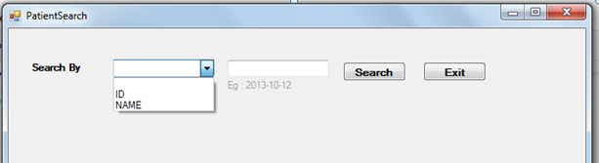

Figure : Search Dialog box

1. To search a patient, user need to select search type in Search By- combo box. Search can be by Patient ID no. or by Name.
   1. Select ID or Name
   2. Enter patient ID no. or Name in search text box
   3. Click Search, then the list of existing patient will be retrieved and can be viewed in the Patient Search dialog box.

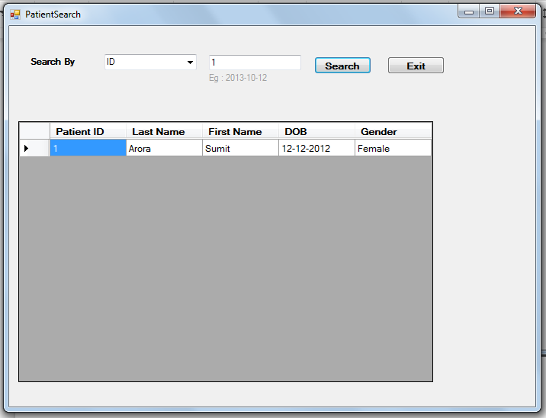

Figure : Search by ID

## 

Figure : Search Patient by Name

If the patient does not exist in the system, a dialog box will be prompted asking “Create New Patient Demography”.

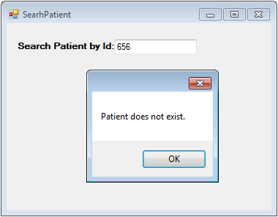

Figure : Search Patient by ID number

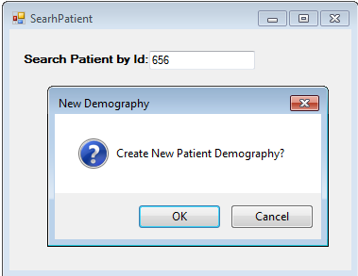

Figure : Create New Patient Demography dialog box

* 1. Click “OK” to create New Patient record. Click “Cancel” to exit.
  2. Create Patient Demographic dialog box will open allowing user to enter demographical data of new patient for registration.

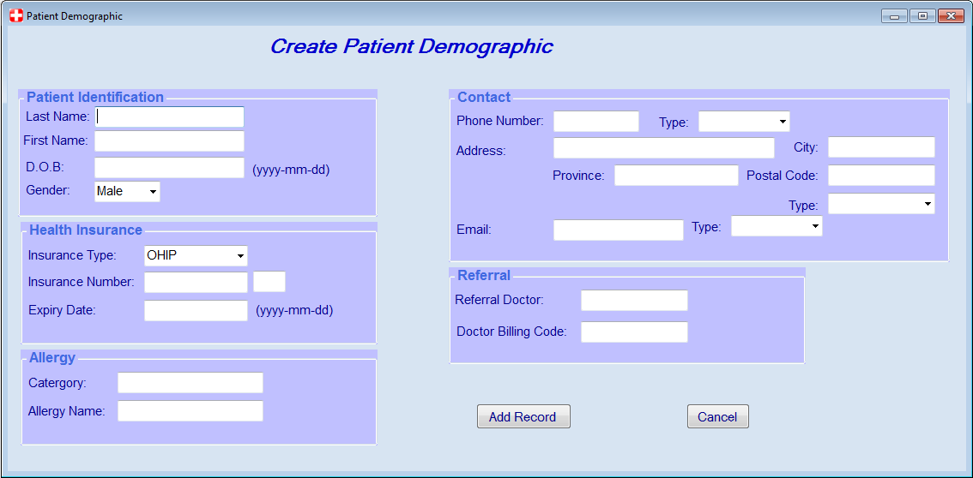

Figure : Create Patient Demography

1. In Create Patient Demographic dialog box-Patient Identification text fields, user can enter the following patient demographic information:
   * + 1. Last Name
       2. Firs Name
       3. Date of Birth (DOB)
       4. Gender
2. On the Contact information text box, user can enter the following information:
   * + 1. Phone Number
       2. Home address
       3. Email address
3. On the Health insurance text box, user can indicate:
   * + 1. Insurance coverage type the patient has.
       2. Insurance No. or Policy No.
       3. Expiry date of coverage
4. Under the Allergy text box, user can indicate patient known allergy and its category type.

1. On the referral text box, user can indicate the name of the referring or consulting doctor including the billing code assigned for the patient.
2. After the user completed all mandatory fields and information, user clicks the Add Record button. A dialog box will pop-up and ask if user would like to see View Demography form of the patient just created.

Updating Patient Demography

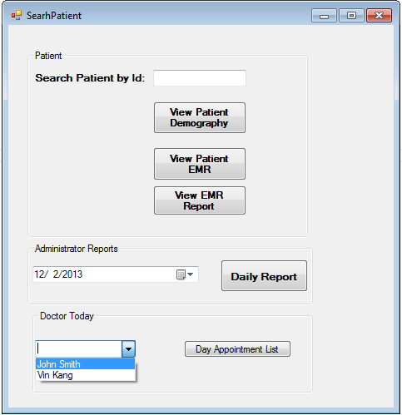

Figure : Search Patient-Updating Demography

1. Enter Patient ID no. in Search Patient by Id text box.
   1. Click View Patient Demography button to retrieve existing patient record.
   2. Patient Demographic user Interface will pop up. Containing Patient Identification, Health Insurance, Allergy, Contact information, and Referral.

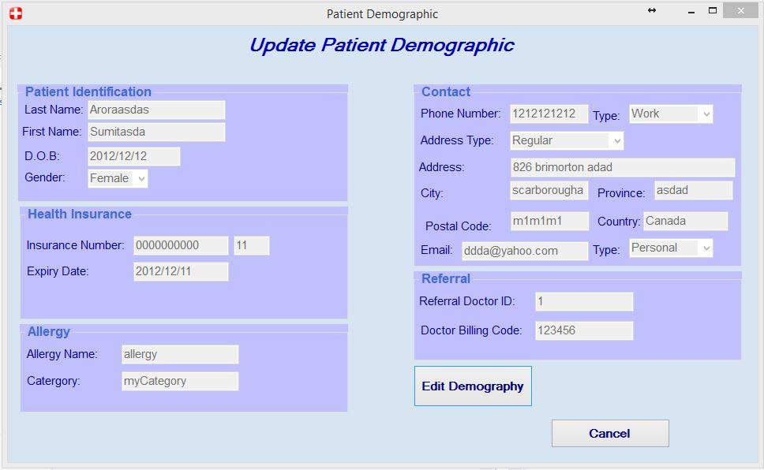

Figure : Update Patient Demographic (with existing record)

* 1. Update Patient Demography
     1. Click Edit Demography in order to edit and update existing demographical data.
     2. Click Cancel button to close Patient Demographic UI.

Viewing Patient Demography

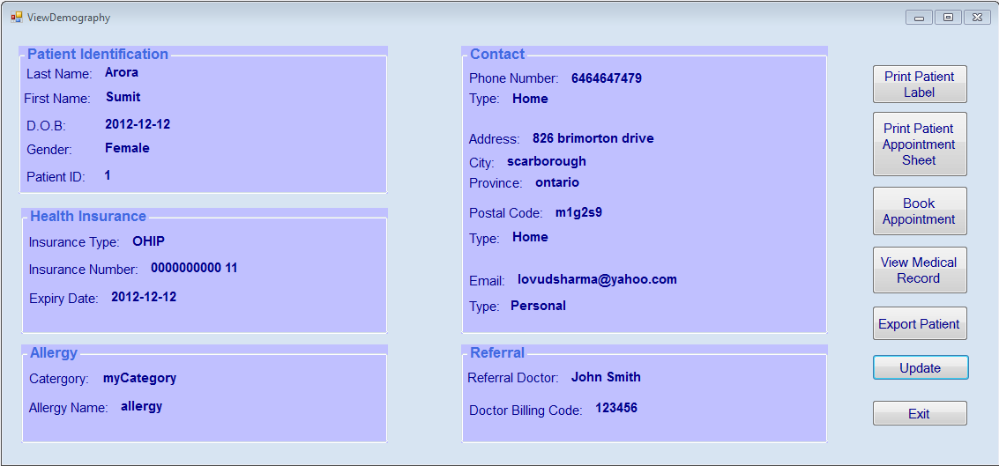

Figure : View Demography Menu Window

1. From the Search Patient window, if the patient is already registered, user can view his/her demographic

1. This view contains sufficient information to identify a patient (by Patient OHIP number)
2. User can have an overview of the patient through this window: name, age, contact, etc
3. There are some functional buttons located on the right side of the window:
   1. User can print Patient Lab by using DYMO Label printer, for example and attach to a lab requisition or referral letter

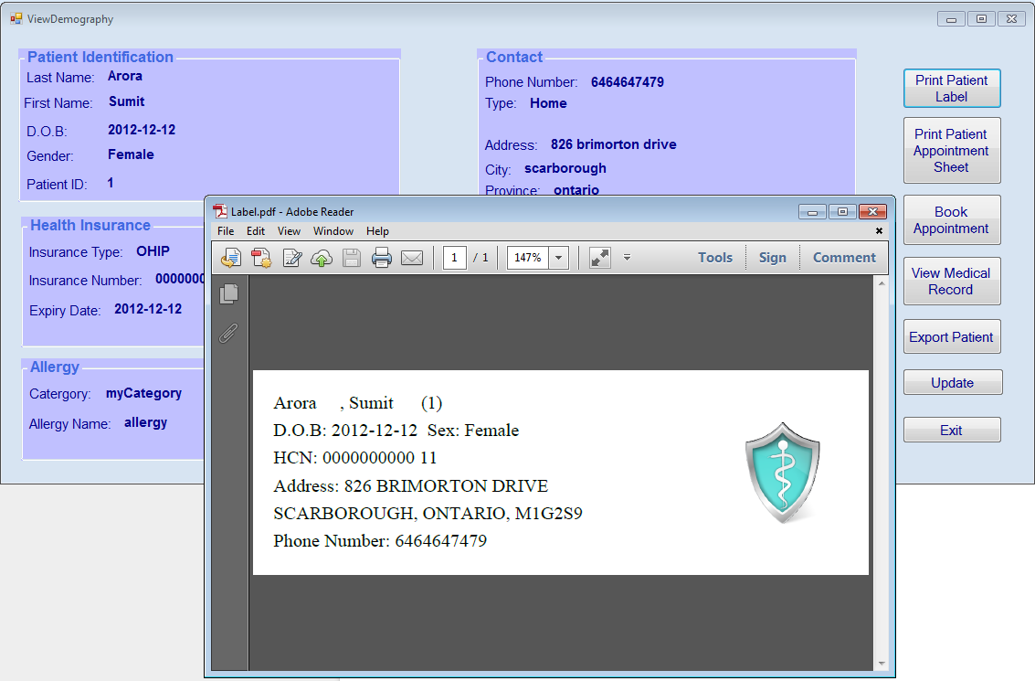

Figure : Sample Label

1. User can print Appointment Sheet. In some clinics, physicians are still using paper chart so they will use this paper to take note when seeing patient. Or it can be used by specialists who want to take notes and dictate after seeing patient.

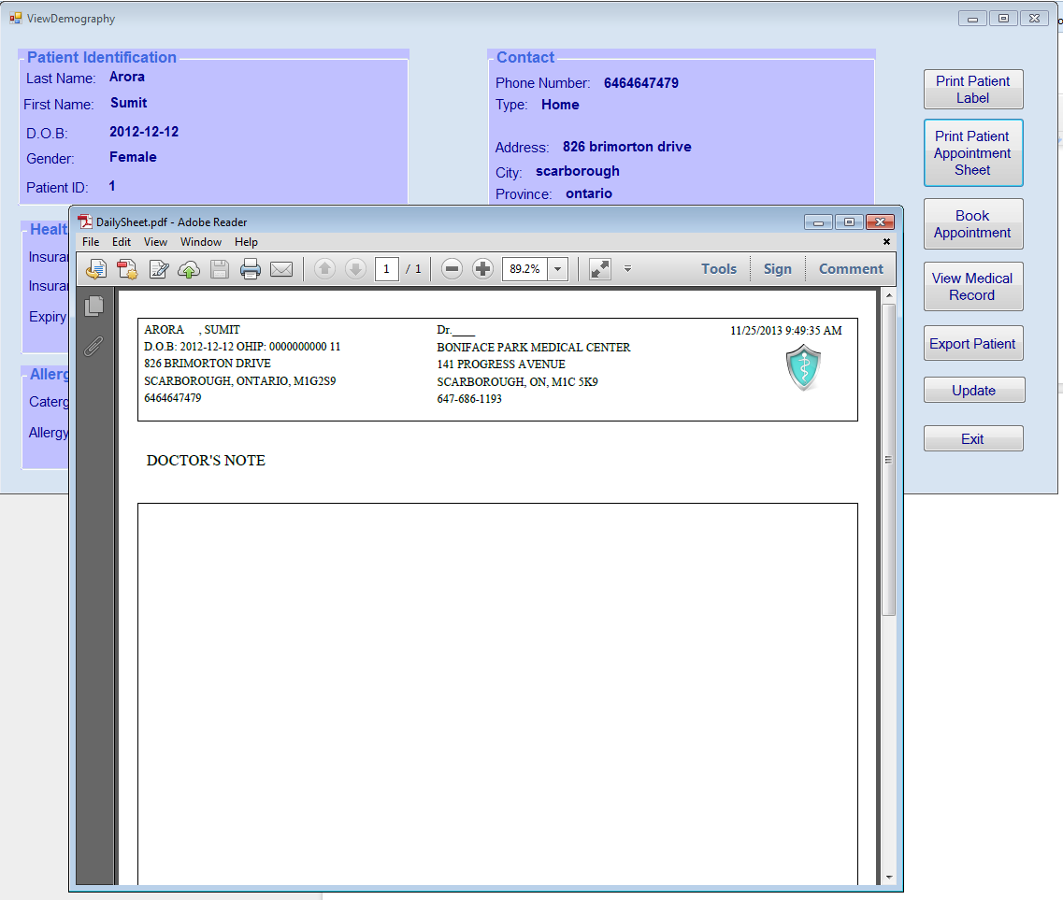

Figure : Doctors’ Note

1. When a patient checks in at front desk, user is able to add patient to a list of the doctor he/she has an appointment today. Note: the drop down list only shows name of the doctor has schedule on that day.  If there is no doctor working on that day, the list will be blank.

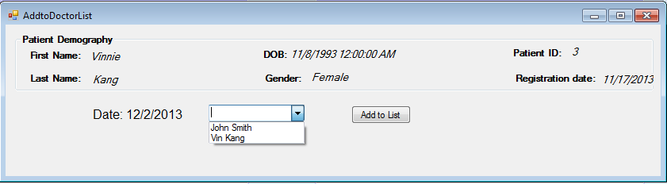

Figure : Add to Doctor List

Entering Patient Assessment

Patient Assessment is an integral part of Computerize Physician Order Entry (CPOE) module. It enables the physician to document clinical observations and assessment of patient during the course of consultation or treatment. It captures the reason for consultation, records vital signs, procedures/test, medicine, clinical impression, and final diagnosis.

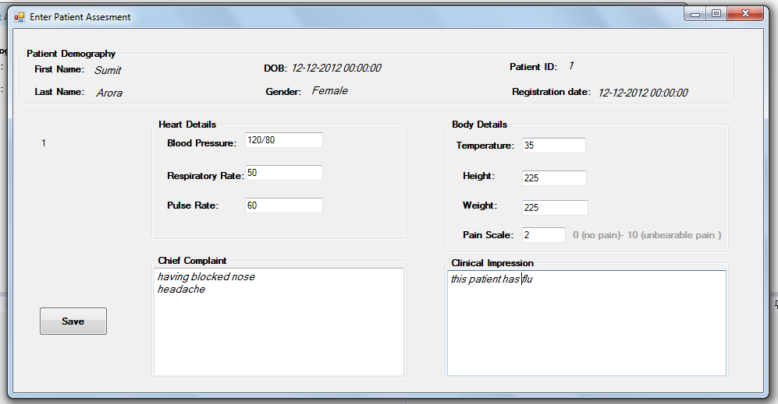

Figure : Patient Assessment window

1. Enter Patient Assessment dialog box contains Patient Demography and text box to indicate and record Assessment.
   1. Doctor enters patient problem list in Chief Complaint text box.
   2. Physical assessment includes-
      1. Enter patient body temperature in Temperature text box.
      2. Height and weight in corresponding ht. & wt. text box.
   3. Pain scale
      1. Enter patient verbalize pain scale based on 0-10 number range, wherein “10” is the highest level that connotes unbearable pain and “0” is the least level that indicates low pain intensity.

* 1. Cardio-respiratory assessment-
     1. Enter patient Blood Pressure in BP text box
     2. Enter patient Respiratory Rate in RR text box
     3. Enter patient Pulse Rate in RR text box

1. Doctors enter patient progress notes in Clinical Impression text box.

1. Enter patient final diagnosis
2. Click Save button to finalize and save patient clinical records.

Viewing Patient EMR

Doctors need to retrieve and view patient medical records in order to have an objective and comprehensive clinical evaluation of patients’ condition. It facilitate the decision support on the part of the clinicians involved the care of patients. Past medical history of patient could drill down to detail information that could help clinicians to have diagnosis and treatment protocol for the patient. Having the information ready and complete will promote efficiency of clinical services including patient safety and quality outcomes.

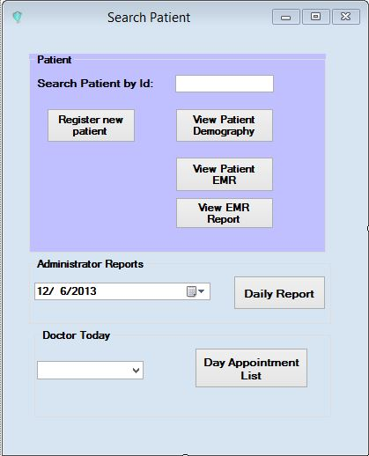

Figure :

1. Enter Patient ID no. in Search Patient by Id text box.
2. View Radiology Procedures
   1. Click View Patient EMR button to retrieve existing patient record.
   2. EMR user interface opens containing Patient Header on top, sort, and view type button.
      1. Select Sort record by (Name, ID, Date and Time)
      2. Click desired record type to view
      3. Click View Radiology button

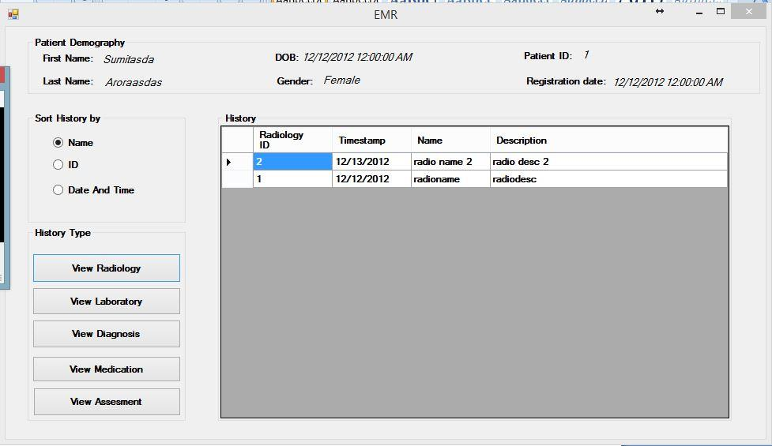

Figure : View EMR-Radiology

* 1. By clicking View Radiology button, Users can see Radiology order history of the patient and can sort them according to Name, ID or Order Date and Time.

The history details include Radiology ID, Time Stamp, Name and Description of that particular Radiology order.

1. View Laboratory Procedures
   1. Click View Patient EMR button to retrieve existing patient record.
   2. EMR user interface opens containing Patient Header on top, sort, and view type button.
      1. Select Sort record by (Name, ID, Date and Time)
      2. Click desired record type to view
      3. Click View Laboratory

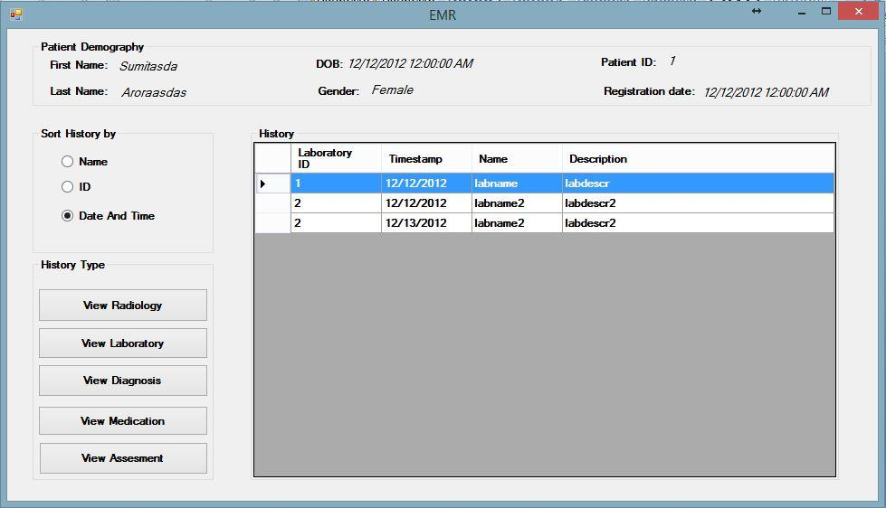

Figure : View EMR-Laboratory

* 1. By clicking View Laboratory button, Users can see Laboratory order history of the patient and can sort them according to Name, ID or Order Date and Time.

The history details include Laboratory ID, Time Stamp, Name and Description of that particular Laboratory order.

1. View Diagnosis
   1. Click View Patient EMR button to retrieve existing patient record.
   2. EMR user interface opens containing Patient Header on top, sort, and view type button.
      1. Select Sort record by (Name, ID, Date and Time)
      2. Click desired record type to view
      3. Click View Diagnosis

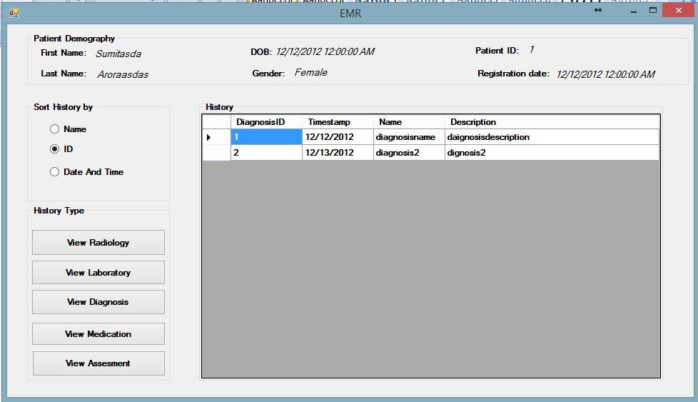

Figure : View EMR-Diagnosis

* 1. By clicking View Diagnosis button, Users can see Diagnosis order history of the patient and can sort them according to Name, ID or Order Date and Time.

The history details include Diagnosis ID, Time Stamp, Name and Description of that particular Diagnosis.

1. View Medication
   1. Click View Patient EMR button to retrieve existing patient record.
   2. EMR user interface opens containing Patient Header on top, sort, and view type button.
      1. Select Sort record by (Name, ID, Date and Time)
      2. Click desired record type to view
      3. Click View Medication

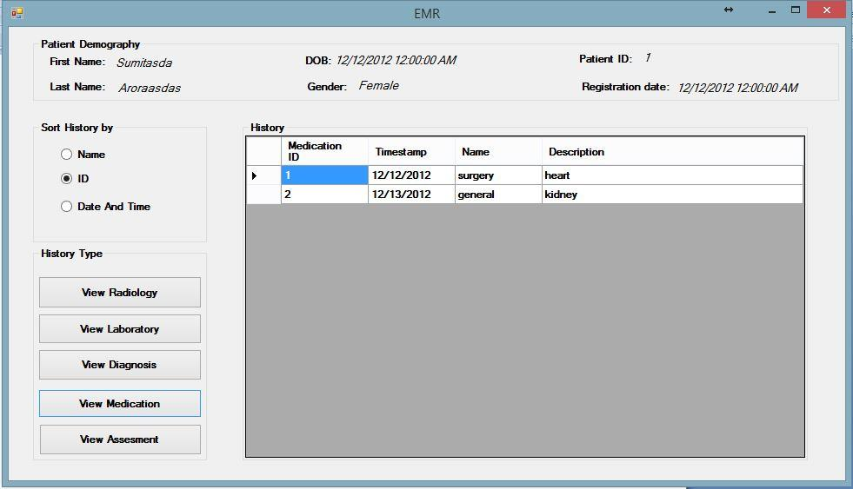

Figure : View EMR-Medication

* 1. By clicking View Medication button, Users can see Medication order history of the patient and can sort them according to Name , ID or Order Date and Time.

The history details include Medication ID, Time Stamp, Name and Description of that particular Medication order.

1. View Assessment
   1. Click View Patient EMR button to retrieve existing patient record.
   2. EMR user interface opens containing Patient Header on top, sort, and view type button.
      1. Select Sort record by (Name, ID, Date and Time)
      2. Click desired record type to view
      3. Click View Assessment

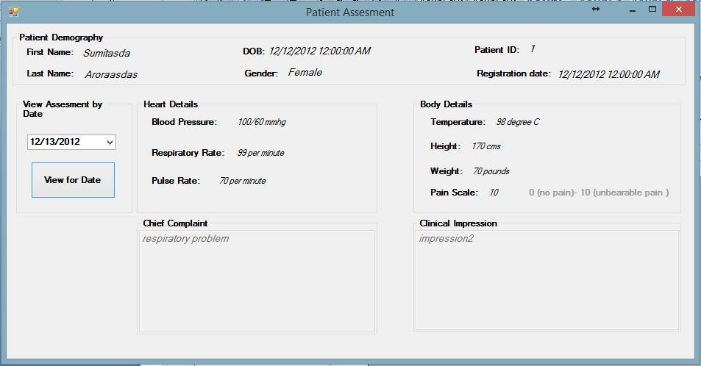

Figure : View EMR-Assessment

* 1. By clicking View Medication button, user can see Patient Information on the top of the View Assessment UI.
  2. Users can select assessment for particular date selecting date from the drop down list and click view for Date to view assessment for selected date.

Generating and Printing of Reports

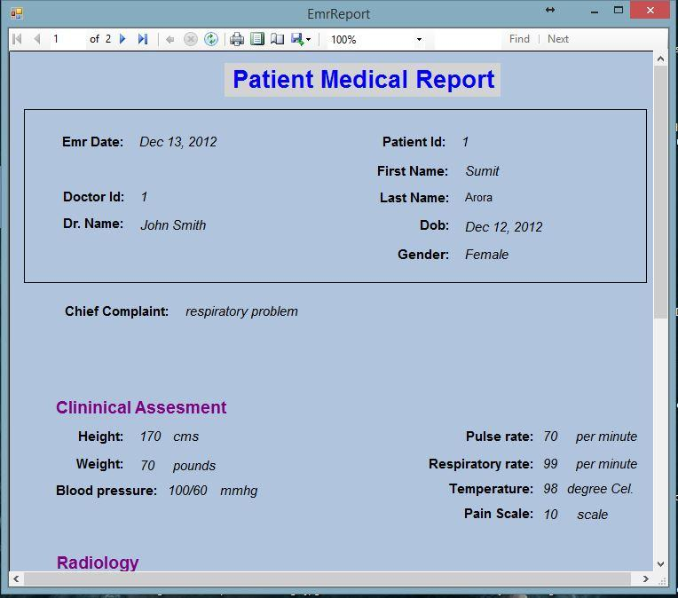

Figure : Patient Medical Report

**View or Print Daily Patient Treated Report**

* 1. Select Date from calendar date selector combo box to identify date of report to generate.
  2. Click Daily Report button.



Figure : Search Patient dialog box

3.0 Daily report will open containing list of patient.

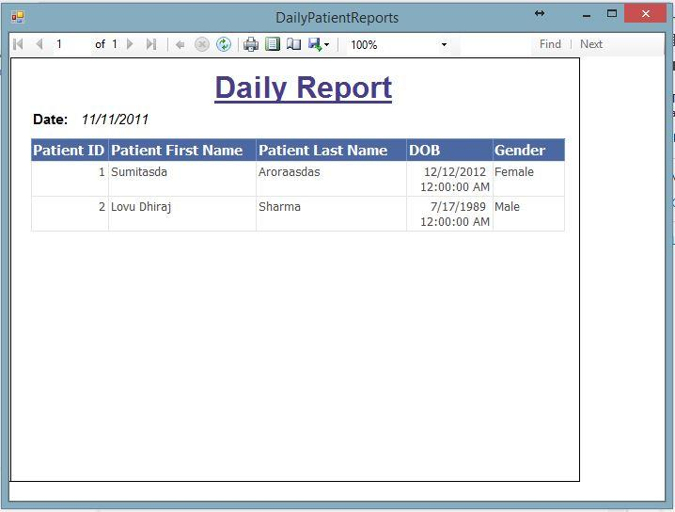

Figure : Daily Report

* Users can see Information of patients treated on particular date. The information like Patient Id , First Name, Last Name , Dob, Gender can be seen for individual patient seen by doctor.

**View or Print Patient Medical Report**

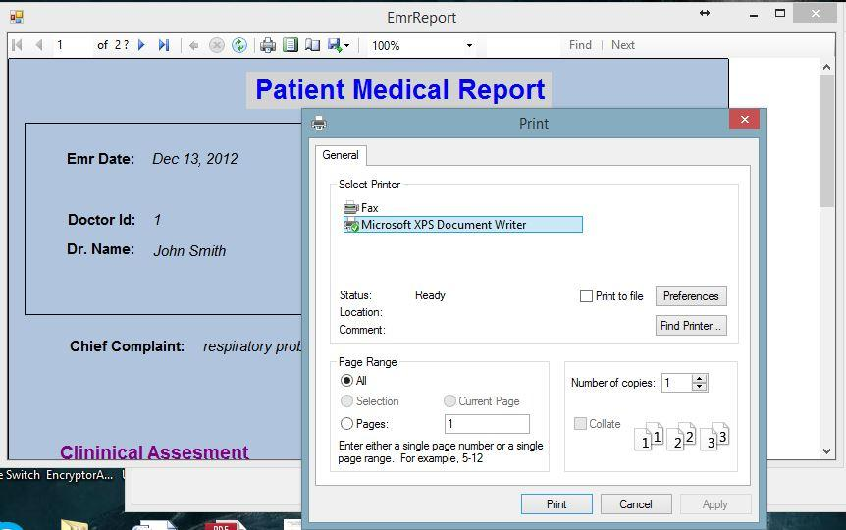

Figure : Printing options

* Users can View Daily Report.
* Users can perform zoom in and zoom out functions on the report.
* Users can go to Next page or enter page number to go to that page number.
* Users can refresh report.
* Users can find word or sentence in the report.
* Users can export the report to various formats like pdf, word or excel format.
* Users can set up print page layout and print report.



Figure : Appointment List

* User can search patient by patient Id and perform the functions like Update patient, View Patient EMR and View EMR Report.
* If patient do not exists user will get Dialogue box will pop up to inform that requested patient does not exist
* If patient exists in the System, Users can perform various functions from this User Interface.
* User can get the appointment list of a specific doctor

Generating Doctor Schedule List

1. In Doctor Today Group box, Select doctors’ name from the combo box of list of doctors available in the system.
2. Click Day Appointment List button to generate the report.
3. Schedule List dialog box will open containing the list of patient schedule of a particular doctor.

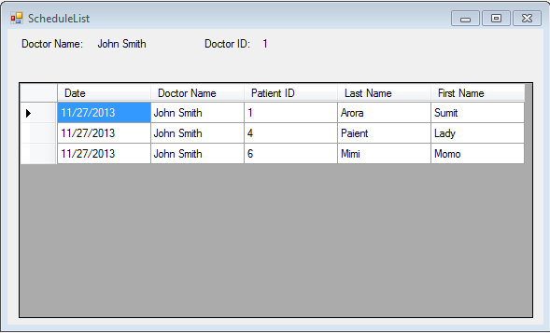

Figure : Schedule List